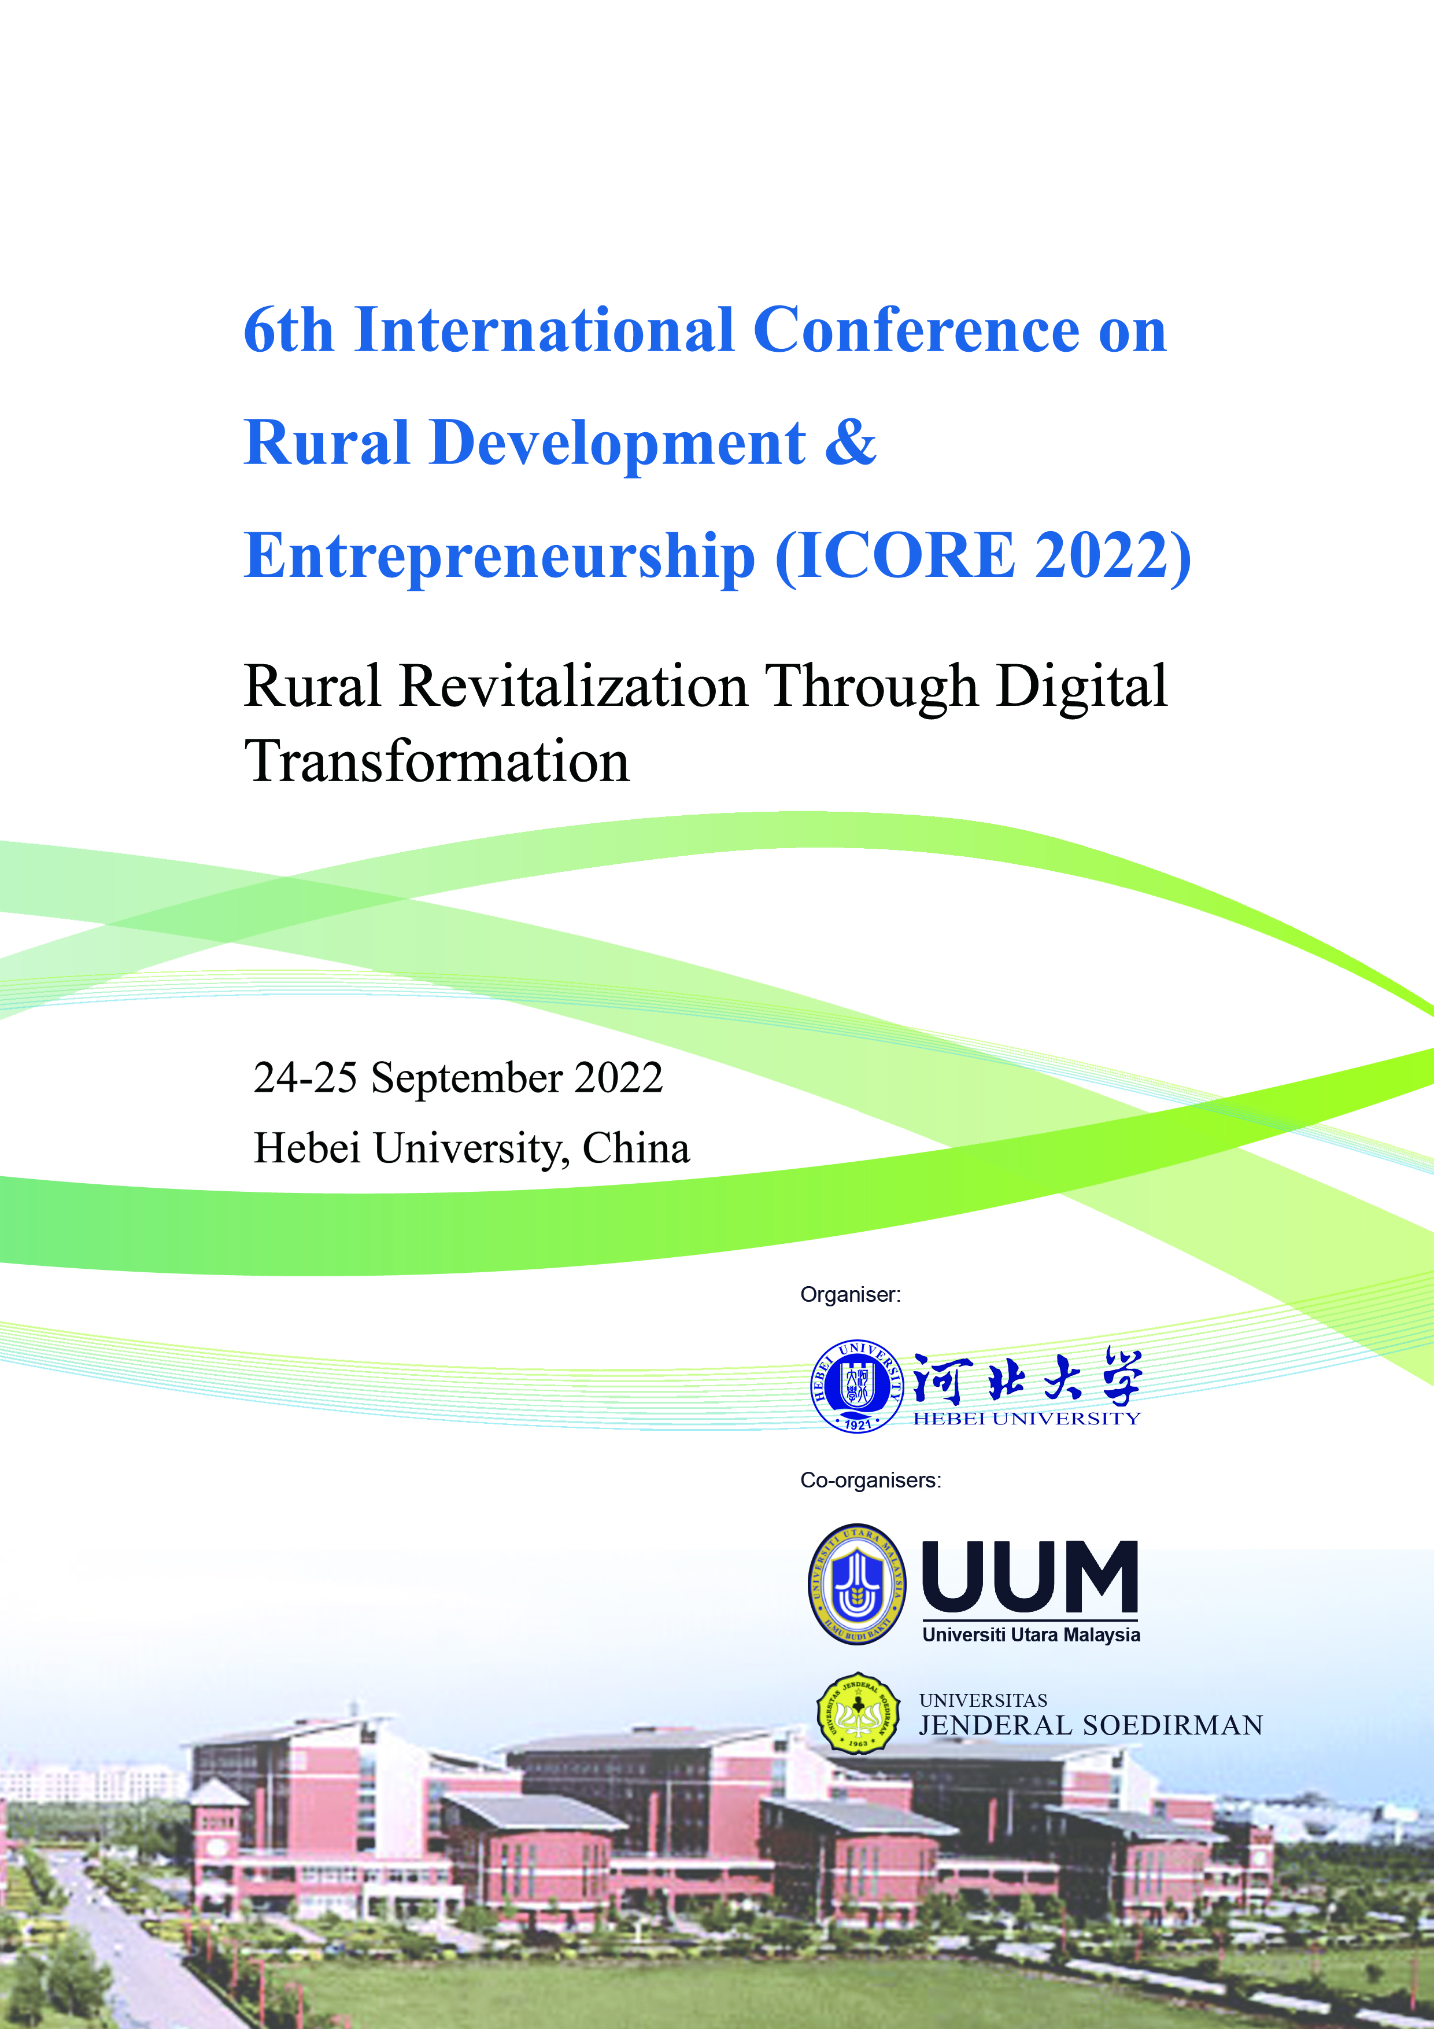

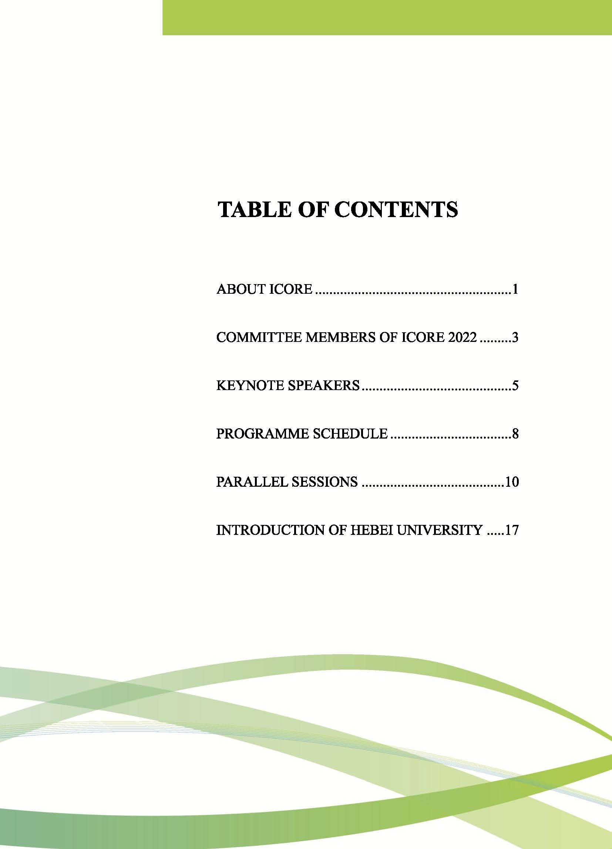

# ABOUT ICORE

The International Conference on Rural Development and Entrepreneurship is an international conference jointly organised by Universiti Utara Malaysia, Hebei University, and Universitas Jenderal Soedirman once every two years. The main focus of the conference is rural development and entrepreneurship. It covers the topics related to economic development, rural tourism and environmental issues, social and information and communications technology (ICT) developments.

The first conference was held in Kuching, Sarawak, Malaysia in May 2011, while the second one was held in Purwokerto, Yogyakarta, Central Java, Indonesia in November 2013. The third conference was held in Hebei University, Baoding, China, in May 2015, followed by the fourth one, which was held in TH Hotel, Alor Setar, Kedah, in November 2017. The latest conference was conducted in Hotel Royal Ambarukmo, Jogjakarta, Indonesia, in August 2019. The conferences have an impressive record of attendance. They have attracted numerous international and local presenters and participants. The attendees have benefited enormously from the lively discussion and presentations sections conducted during the conference. Many ideas have been shared and brainstormed in the conferences.

**Conference Objectives**

1. The target audience is academic institutions, research organizations, government agencies, policymakers, public policy advocates, non-governmental organizations (NGOs), and corporate representatives.
2. This conference serves as a meeting point for scholars and stakeholders to interact and exchange ideas. It is also an opportunity for the participants to exchange ideas and disseminate new research findings, which can be used for future research and policy formulation.
3. It is also in the best interest of the organizer to further generate innovative thinking pertaining to rural development and to identify elements of a long-term research agenda to fill critical gaps in knowledge on these issues.

**Main Theme**

Rural Revitalization Through Digital Transformation

**Sub-themes**

1. Technology, innovation and creativity in rural development
2. Rural poverty eradication and reaching the rural poor
3. Entrepreneur education and skills attainment
4. Entrepreneurship as an economic development vehicle of rural communities
5. Environmental and tourism sustainability of rural areas
6. The rural way of life and quest for development
7. Digital economy and digital finance on rural areas
8. International Comparisons of Rural Development Policies

# COMMITTEE MEMBERS OF ICORE 2022

**Advisory Committee**

Prof. Dr. Wang Pei Guang (HBU)

Prof. Dr. Shen Shi Gang (HBU)

Prof. Dr. Xu Jian Min (HBU)

Assoc. Prof. Dr. Bakti Hasan Basri (UUM)

Assoc. Prof. Dr. Siti Aznor Hj. Ahmad (UUM)

Prof. Wiwiek Rabiatul Adawiyah (UNSOED)

**Chairman**

Prof. Dr. Cheng Xin Xuan (HBU)

**Vice-Chairman**

Prof. Dr. Zhang She Lie (HBU)

Prof. Dr. Zhu Chang Cun (HBU)

**Co-Chairman**

Assoc. Prof. Dr. Cheah Yong Kang (UUM)

Dr. Yudha Aryo Sudibyo (UNSOED)

**Secretary**

Assoc. Prof. Dr. Guo Xiao Hui (HBU)

Ms. Zhang Mei (HBU)

Dr. Tan Bee Wah (UUM)

**Vice-Secretary**

Assoc. Prof. Kong Chang (HBU)

**Treasurer**

Ms. Zhang Li Li (HBU)

Dr. Rozana Samah (UUM)

**Technical Committee**

Prof. Dr. Yin Cheng Yuan (HBU)

Prof. Dr. Yang Wen Jie (HBU)

Mr. Xia Xue Cang (HBU)

Mr. Ma Hui (HBU)

Prof. Dr. Ma Wen Xiu (HBU)

Prof. Dr. Zhou Wen Hai (HBU)

Prof. Dr. Xi Zeng Lei (HBU)

Prof. Dr. Hu Yan Ling (HBU)

Prof. Dr. Wang Peng Gang (HBU)

Prof. Dr. Yuan Qing Chuan (HBU)

Assoc. Prof. Dr. Zhang Xiao Hua (HBU)

Assoc. Prof. Dr. Wang Li Hua (HBU)

Dr. Dong Chi (HBU)

Ms. Tang Wen (HBU)

Dr. Nur Adeelah Che Ahmad Tantowi (UUM)

**Coordination Committee**

Assoc. Prof. Zhou Ning (HBU)

Prof. Dr. Guo Yan Bin (HBU)

Prof. Dr. Xing Hui Bin (HBU)

Assoc. Prof. Dr. Gu Yan Feng (HBU)

Prof. Dr. Zhao Lin Tao (HBU)

Assoc. Prof. Jin Tian Xing (HBU)

**Promotion & Media**

Mr. Jia Hao Jie (HBU)

Mr. Li Ang (HBU)

Assoc. Prof. Dr. Logasvathi Murugiah (UUM)

**Proceedings & Publication**

Prof. Dr. Lim Hock Eam (UUM)

Muhammad Farid Alfarisy (UNSOED)

**Logistic**

Assoc. Prof. Peng Shu Lin (HBU)

Ms. Wang Yong Hui (HBU)

**Webpage**

Assoc. Prof. Ding Ying Hui (HBU)

# KEYNOTE SPEAKERS

**Xing Hui Bin**

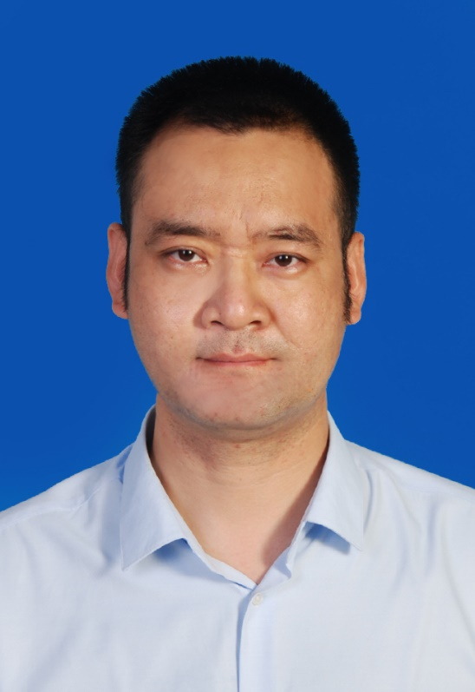

Xing Hui Bin, a professor of Hebei University, China, obtained his Ph.D. degree from Universiti Sains Malaysia. Prof. Xing conducted his post-doctoral research at the Chinese Academy of Science. Prof. Xing’s fields of research consist of cultural tourism, heritage tourism, cross-cultural communication, and community participation. Prof. Xing has published more than a hundred research articles in peer-reviewed journals. He also completed several national and provincial level research projects.

**Shri Dewi Applanaidu**



Assoc. Prof. Dr. Shri Dewi Applanaidu is attached to the Department of Economics and Agribusiness, School of Economics, Finance and Banking (SEFB), Universiti Utara Malaysia (UUM).

Her research interests are in the area of Agricultural Econometric Modeling, Agricultural Economics and Food Security. She also has produced several publications nationally and internationally in the form of journal articles, book, chapter in books and proceedings. She is also an active researcher in the national and international level. Her keens in innovation enable she and her team won two (2) gold and two (2) silver medals in the International Innovation Exhibitions. She also owns 11 copyrights and one (1) licensing for their innovations. In terms of consultation, she has been appointed as a Short Term Consultant for two World Bank projects entitled “Towards a New Approach for Malaysia’s Paddy and Rice Policy” in 2020 and “Agricultural Transformation and Inclusive Growth” in 2018. She has also completed a consultation with Federal Agricultural Marketing Authority (FAMA), Council of Palm Oil Producing Countries (CPOPC) and Universitas Indonesia (UI).

**Abdul Aziz Ahmad**

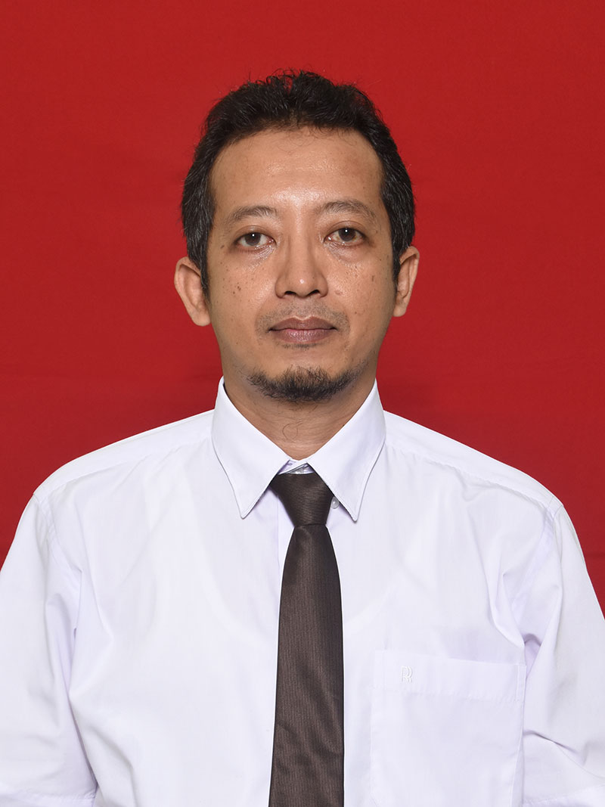

Dr. Abdul Aziz Ahmad is the Head of Doctor in Economics Program in Faculty of Economics and Business, Universitas Jenderal Soedirman, Indonesia. He received his bachelor, master and doctoral program from Universitas Gadjah Mada, Indonesia. He teaches undergraduate and postgraduate program in Department of Economics and Development Studies, Faculty of Economics and Business, Universitas Jenderal Soedirman. His research interest is regional economics.

# PROGRAMME SCHEDULE

Notes: All the time is Chinese time.

|  |  |
| --- | --- |
| **TIME/VENUE** | **EVENT** |
| **Day 1: 24 September 2022** | |
| **Opening Ceremony**: Offline Venue：B1-217 Voovmeeting: 201 955 246 | |
| 8.30 am – 9.00 am | Registration |
| 9.00 am – 9.30 am | **WELCOMING SPEECH**  Chairperson: **Prof. Dr. Cheng Xin Xuan**  Dean, School of Economics, HBU   1. **Prof. Dr. Shen Shi Gang**   Vice President, HBU 10 minutes   1. **Associate Prof. Dr. Roslina Binti Kamaruddin**   Director of Economic & Financial Policy Institute, UUM  10 minutes   1. **Prof. Dr. Akhmad Sodiq, M.Sc. Agr**   The Rector of UNSOED, Indonesia 10 minutes |
| 9.30 am – 9.50 am | Tea Break |
| 9.50 am – 11.50 pm | **KEYNOTE SPEECH**  Chairperson: **Assoc. Prof. Fu Hong Yan**  Vice dean, School of International Exchange and Education, HBU  **1. Prof. Dr. Xing Hui Bin**  School of Management, HBU  Title: A Theoretical Assessment Model of Community Participation in Red Tourism from the Tourism Planner’s Perspective  30 minutes  **2. Assoc. Prof. Dr. Shri Dewi Applanaidu**，  School of Economics, Finance and Banking, UUM  Title: Food Security in Malaysia: Challenges and Opportunities  30 minutes  **3. Dr. Abdul Aziz Ahmad**，  Faculty of Economics and Business, Universitas Jenderal Soedirman, Indonesia, UNSOED  Title: Strengthen the resilience of the agricultural sector after COVID-19 pandemic 30 minutes  **4. Questions and Discussions** 30 minutes |
| 12.30 pm – 2.00 pm | Lunch break |
| 2.00 pm – 3.30 pm | **Parallel session 1**  **Session 1A**: Entrepreneurship as an economic development vehicle of rural communities -01  Venue：B1-217 Voovmeeting: 629 256 512  **Session 1B**: Rural poverty eradication and reaching the rural poor -01 Venue：B1-317 Voovmeeting: 392 151 358  **Session 1C**: The rural way of life and quest for development  Venue：B4-307 Voovmeeting: 566 472 491 |
| 3.30 pm – 5.00 pm | **Parallel session 2**  **Session 2A**: International Comparisons of Rural Development Policies  Venue：B1-217 Voovmeeting: 629 256 512  **Session 2B**: Digital Economics on rural areas-01  Venue：B1-317 Voovmeeting: 392 151 358  **Session 2C**: Technology, innovation and creativity in rural development  Venue：B4-307 Voovmeeting: 566 472 491 |
|  |  |
| **Day 2: 25 September 2022** | |
| 8.30 am – 10.00 am | **Parallel session 3**  **Session 3A**: Entrepreneurship as an economic development vehicle of rural communities -02  Venue：B1-217 Voovmeeting: 670 424 469  **Session 3B**: Rural poverty eradication and reaching the rural poor -02  Venue：B1-317 Voovmeeting: 317 768 037  **Session 3C**: Digital Finance on rural areas  Venue：B4-307 Voovmeeting: 664 942 873 |
| 10.00 am–10.30 am | am Tea break |
| 10.30 am–12.00 pm | **Parallel session 4**  **Session 4A**: Rural poverty eradication and reaching the rural poor -03  Venue：B1-217 Voovmeeting: 670 424 469  **Session 4B**: Digital Economics on rural areas-02  Venue：B1-317 Voovmeeting: 317 768 037  **Session 4C**: Entrepreneur education and skills attainment  Venue：B4-307 Voovmeeting: 664 942 873 |
| 12.00 pm – 2.30 pm | Lunch break |
| 2.30 pm – 4.00 pm | **Parallel session 5**  **Session 5A**: Entrepreneurship as an economic development vehicle of rural communities -03  Venue：B1-217 Voovmeeting: 880 316 208  **Session 5B**: Environmental and tourism sustainability of rural areas  Venue：B1-317 Voovmeeting: 191 595 001 |
| 4.00 pm – 5.00 pm | **CLOSING CEREMONY**  Offline Venue：B1-217 Voovmeeting: 880 316 208  Chairperson: Prof. Dr. Cheng Xin Xuan (Dean, School of Economics, HBU)  **1. Summary of ICORE2022**  **2. Closing ceremony speech by next organiser**  **Assoc. Prof. Dr. Rasidah binti Mohd Rashid**  Deputy dean of School of Economics, Finance and Banking, UUM |

# PARALLEL SESSIONS

DAY 1: 24 September 2022

|  |
| --- |
| Parallel session 1: 2.00 pm – 3.30 pm, 24 September 2022 |
| **1A: Entrepreneurship as an economic development vehicle of rural communities -01** |
| **Venue: B1-217 Voovmeeting: 629 256 512** |
| **Chair: Syaeful Bakhri** |
| 1. Fashion, Craft, Culinary and Performing Arts Are the Leading Sub-Sectors of the Creative Economy of Cirebon Regency  Syaeful Bakhri, Suharno, Abdul Aziz Ahmad |
| 2. Relationship of Macroeconomic Policies with Stunting: The Role of The Health Budget, Applying Fiscal Autonomy and Reducing Poverty  Maman Sulaeman, Suharno, Abdul |
| 3. The Impact of Commodity Price Volatility on China's Agricultural Chain  Hu Shu Kun, Xi Zeng Lei |
| 4. The Effect of The Foreign Aid on Economic Growth— Based on the Perspective of the Donor Countries  Qiao Min Jian, Zhang Li Jun, Meng Hong Li |

|  |
| --- |
| Parallel session 1: 2.00 pm – 3.30 pm, 24 September 2022 |
| **1B: Rural poverty eradication and reaching the rural poor -01** |
| **Venue: B1-317 Voovmeeting: 392 151 358** |
| **Chair: Gao Yuan** |
| 1. Research on the Support of the Poor Elderly in Rural Areas  Yang Wen Jie, Li Xuan |
| 2. Market Structure, Product Specificity and Agricultural Supply Chain Finance ——A Case Study on CCP Cooperative  Song Ya Nan |
| 3. Research on the Sustainable Development of Tourism in Hebei Province from the Perspective of Rural Revitalization  Bao Fu Rong, Li Jiao |
| 4. Research on Consumption Upgrading of Rural Residents in Hebei Province  Qian Yu, Chen Li Sha and Jia Kai Yue |

|  |
| --- |
| Parallel session 1: 2.00 pm – 3.30 pm, 24 September 2022 |
| **1C: The rural way of life and quest for development** |
| **Venue: B4-307 Voovmeeting: 566 472 491** |
| **Chair: Wang Peng Gang** |
| 1. Research on Rural-Urban Differences in Social Participation of the Elderly and Their Self-rated Health Implications  Cui Hong Wei, Sang Yu Yue, Wang Yan |
| 2. Contribution of Population Growth, Agricultural Land Use and Inflation to Poverty  Maman Sulaeman, Suharno, Abdul Aziz Ahmad |
| 3. The Impact of Grandparent Care on Adolescents’ Non-cognitive Abilities  Li Rui, Liu Ying, Hao Xiao |
| 4. A Study on the Impact of Boarding on Children's Human Capital: From the Perspective of Cognitive and Non-Cognitive Abilities  Zhai Chao, Kuang Sheng Jie, Li Rui |

|  |
| --- |
| Parallel session 2: 3.30 pm – 5.00 pm, 24 September 2022 |
| **2A: International Comparisons of Rural Development Policies** |
| **Venue: B1-217 Voovmeeting: 629 256 512** |
| **Chair: Zhang Xiao Hua** |
| 1. The Impact of the RCEP Tariff Reduction Schedule in China-Japan in Goods ——Based on the Analysis of GTAP Model  Ma Wen Xiu, Li Rui Yuan |
| 2. The Influence Effect of Regional Trade Agreement Network Structure on Two-way FDI  Liu Xu, Xi Zeng Lei |
| 3. The Impact of CAFTA Trade & Investment Facilitation on Digital Trade in China  Zhang Xiao Hua, Zhang Zhi Xuan, Huang Zhi Ping |
| 4. The Effects of Foreign Direct Investment on Africa’s Economic Growth  Zhou Wen Hai, Agu Okwudili Chijioke (Zhou Xin Yu, Chinese name) |
| 5. Comparative Study on Agricultural Support Policies in India and Brazil and Its Enlightenment  Xu Yong Li, Yuan Meng Fan |

|  |
| --- |
| Parallel session 2: 3.30 pm – 5.00 pm, 24 September 2022 |
| **2B: Digital Economics on rural areas -01** |
| **Venue: B1-317 Voovmeeting: 392 151 358** |
| **Chair: Yang Guo Qing** |
| 1. The Development Model of Rural Digital Economy for Rural Revitalization  Gao Yuan |
| 2. The Impact of Digital Economy on Rural Industry Revitalization in China  Li Yuan Tian, Li Rui |
| 3. Research on Evaluation of Development Level of Digital Economy Based on Combination Weighting Method and Improved VIKOR Method  Guo Zi Xue, Liu Si Jia |
| 4. Analysis on The Construction Path of Digital Village from the Perspective of Rural Revitalization  Yang Wen Jie, Lv Shao Ming |
| 5. Rural Entrepreneurship in the Digital Economy: Research Review and Outlook  Shi Haozhe, Niu Nan |

|  |
| --- |
| Parallel session 2: 3.30 pm – 5.00 pm, 24 September 2022 |
| **2C: Technology, innovation and creativity in rural development** |
| **Venue: B4-307 Voovmeeting: 566 472 491** |
| **Chair: Xi Zeng Lei** |
| 1. Technological Innovation and Firm Performance in The Beijing-Tianjin-Hebei Equipment Manufacturing Industry: The Moderating Role of Firm Growth  Wang He, Xi Zeng Lei |
| 2. Ownership, Competition and Companies’ Technical Level  Wang Wei |
| 3. The Influence of Technology Complexity in Productive Service Imports on Enterprise Digital Transformation  Wang Yue, Wang Li Jun |
| 4. Strategies That Encourage Entrepreneurial Students in The Covid-19 Pandemic Period  Afifah Amalia Zahra, Dewi Susilowati, Hijroh Rokhayati |

PARALLEL SESSIONS

DAY 2: 25 September 2022

|  |
| --- |
| Parallel session 3: 8.30 am – 10.00 am, 25 September 2022 |
| **3A: Entrepreneurship as an economic development vehicle of rural communities -02** |
| **Venue: B1-217 Voovmeeting: 670 424 469** |
| **Chair: Wang Li Hua** |
| 1. Study of Sector Determination and Leading Food Crops Commodities  Suharno Suharno, Arif Andri Wibowo, Muhammad Farid Alfarisy |
| 2. Price Cascade Transmission Effects of International Crude Oil on Chinese Energy Stocks: A Multi-Scale View  Yu Jin Xiu, Xi Zeng Lei |
| 3. The Impact of Social Security for Unpaid Workers in the European Union on Gender Income Equality and Enlightenment to China  Feng Xiao (Hebei University of Economics and Business) |
| 4. Heterogeneity Analysis of Inbound Tourism to Regional Economic Growth in China  Wang Li Hua, Liu Yu Han, Wang Hong Li |

|  |
| --- |
| Parallel session 3: 8.30 am – 10.00 am, 25 September 2022 |
| **3B: Rural poverty eradication and reaching the rural poor -02** |
| **Venue: B1-317 Voovmeeting: 317 768 037** |
| **Chair: Assoc. Prof. Dr. Cheah Yong Kang** |
| 1. Talent Dilemma and Educational Response for the Development of New Agricultural Management Entities under Rural Revitalization  Xu Shu Lin, Li Kai Le, Chen Shang Xiu |
| 2. Research on the Path of Improving the Quality of Elderly Health Services in Rural China under the Background of Rural Revitalization  Zhang Chang Bao, Hu Yao Ling |
| 3. China's Rural Population Development Characteristics and Trend Forecast——Based on Previous Census Data  Wang Peng Gang, Wu Xing Yu |
| 4. Revitalizing Agriculture Through Digital Commerce and Rural Revitalization in Hebei Province  Pei Gui Fen, Chang Jia Chen |

|  |
| --- |
| Parallel session 3: 8.30 am – 10.00 am, 25 September 2022 |
| **3C: Digital finance on rural areas** |
| **Venue: B4-307 Voovmeeting:** 664 942 873 |
| **Chair: Dong Chi** |
| 1. Does Green Finance Promote Carbon Emission Reduction？Evidence from China  Zhou Wen Hai, Zhang Miao, Wu Xiao Min |
| 2. Development of Heilonggang Basin Financial Support Area from the Perspective of Rural Revitalization  Ren Li Yong |
| 3. The Impact and Heterogeneity of Digital Inclusive Finance Development on Poverty Alleviation --Based on County-level Panel Data in Jing-Jin-Ji Region  Gao Xiao Kun, Guo Xiao Hui |
| 4. The Effective Ways for Digital Inclusive Finance to Promote Rural Revitalization  Hou Jun Ran |

|  |
| --- |
| Parallel session 4: 10.30 am – 12.00 pm, 25 September 2022 |
| **4A: Rural poverty eradication and reaching the rural poor -03** |
| **Venue: B1-217 Voovmeeting: 670 424 469** |
| **Chair: Sun Yi Fan** |
| 1. Analysis on the Level of Equalization of Basic Public Services in China Under the Background of Common Prosperity——Based on TOPSIS and obstacle diagnosis model  Song Feng Xuan, Wang Li, Song Bao Lin |
| 2. Advance Agricultural, Rural Modernization and Make New Progress in Rural Revitalization  Yang Wen Jie, Zhang Shan Shan |
| 3. The Influence of Human Capital Heterogeneity on Agricultural Development Efficiency—— Empirical Evidence from China’s Provincial data  He Miao, Cui Li Wei, Chen Sheng Wei |
| 4. An Analysis of the Effect of Urbanization on Poverty Reduction in Rural China  Sun Yi Fan, Liu Shuai, Li Ming Xin |
| 5. Research on the Gender Wage Gap of Migrants Based on Industry Segregation  Yuan Qing Chuan, Zhang Zi Peng |

|  |
| --- |
| Parallel session 4: 10.30 am – 12.00 pm, 25 September 2022 |
| **4B: Digital Economics on rural areas -02** |
| **Venue: B1-317 Voovmeeting: 317 768 037** |
| **Chair: Prof. Dr. Lim Hock Eam** |
| 1. Analysis of Coupling harmonious Capability of Science and Technology Service Industry and Advanced Manufacturing Industry in Hebei Province  Guo Fang Chen |
| 2. Research on Optimization of Cold Chain Logistics Network in Uncertain Environment  Zhang Yun Tong, Guo Zi Xue and Zhu Xiao Liang |
| 3. Research on The Heterogeneity and Mechanism of the Impact of E-commerce Development on Rural Residents' Income  Chen Nan Nan, Zhu Chang Cun, Ma Zhi Jie |
| 4. Empirical Research on Model of Labor Attraction for Urban Digital Industry  Yang Xiu Dan, Wang Feng Qi |

|  |
| --- |
| Parallel session 4: 10.30 am – 12.00 pm, 25 September 2022 |
| **4C: Entrepreneur education and skills attainment** |
| **Venue: B4-307 Voovmeeting: 664 942 873** |
| **Chair: Shafira Alifiana Elmira** |
| 1. The Effect of Corporate Governance and Ownership Structures on Audit Fees  Shafira Alifiana Elmira, Dona Primasari, Puji Lestari |
| 2. Does Corporate ESG Performance Boost Corporate Value? ——Based on The Heterogeneity of Institutional Investors  He Le, Li Hao Ran |
| 3. Credit Guarantee Loan Contract with Coguarantee in a Capital-constrained Supply Chain: Equilibrium and Coordination Strategy  Zhu Xiao Liang, Guo Zi Xue and Yang Guo Qing |
| 4. Examining Causality of Capital Towards Liquidity Creation by Involving the Contribution of Managerial Ability Committed to Credit Effectivity  Sri Lestari, Imam Ghozali, Najmudin |

|  |
| --- |
| Parallel session 5: 2.30 pm – 4.00 pm, 25 September 2022 |
| **5A: Entrepreneurship as an economic development vehicle of rural communities -03** |
| **Venue: B1-217 Voovmeeting: 880 316 208** |
| **Chair: Rio Dhani Laksana** |
| 1. Research on The Digital Transformation Path of China's Rural Commercial Banks  Zhang Yu Mian, Feng Lu Yao |
| 2. The impact of residents’ digital finance participation on commercial banks: Evidence from 174 Commercial Banks in China  Fang Huai Zheng, Guo Xiao Hui |
| 3. Risk Decision Making Investment of Young Investors in Indonesia  Rio Dhani Laksana, Intan Shaferi |
| 4. The Impact of Industrial Policy on Firm Investment Efficiency: Based on Investor Sentiment  Dong Chi, Wang Chao, Dong Yang |

|  |
| --- |
| Parallel session 5: 2.30 pm – 4.00 pm, 25 September 2022 |
| **5B: Environmental and tourism sustainability of rural areas** |
| **Venue: B1-317 Voovmeeting: 191 595 001** |
| **Chair: Ding Ying Hui** |
| 1. Evaluation of Urban Soil Pollution Based on Complex Network: A Case Study of Huanghua City  Hou Mei Yi, Sun Qing Ru, Xi Zeng Lei |
| 2. High-resolution Mapping of China’s Lithium Recycling Potential in Electric Passenger Vehicles Across 355 cities: 2014-2022  Zheng Lin Chang, Hu Yu Qi, Chen Ge |
| 3. Time-Varying Causality of Energy Stock Markets from Multi-Dimensional Perspective  Zhao Wenqi, Xi Zenglei, Sun Qingru |
| 4. Multiscale Comovement of the Dynamic Correlations Between Copper Futures and Spot Prices  Ding Ying Hui |
| 5. A Theoretical Model of Cultural Heritage Tourism from the Perspective of Community Participation  Xing Hui Bin, Azizan Marzuki |

**Notes:**

**How to use Voovmeeting?**

1. Download Voovmeeting

<https://voovmeeting.com/download-center.html?from=1001>

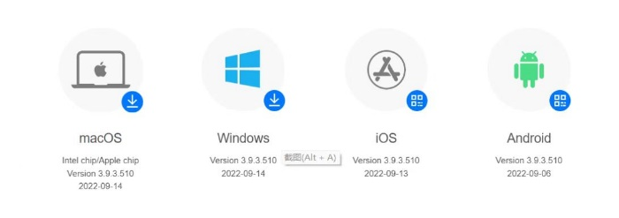



1. According to Voovmeeting ID, entering the meeting room.

# INTRODUCTION OF HEBEI UNIVERSITY

As a key comprehensive university, Hebei University (HBU) is co-constructed by Ministry of Education, the People's Government of Hebei Province and State Administration of Science, Technology and Industry for National Defense of PRC. It is also one of the first-level universities participating in China's construction plan of national first-class university and world-class disciplines, with strong support from the Hebei Provincial Government.

Covering an area of approximately 162 hectares, the university is consisted of the Main Campus, the New Campus and the Medical School, with the construction area of 1.29 million square meters. There are 27 secondary colleges, 15 first-level disciplines authorized to offer doctoral degrees, 46 first-level disciplines authorized to award master degrees, 26 disciplines authorized to offer professional master degrees, 11 disciplines authorized to offer master degrees of engineering, and 94 undergraduate programs. As one of the universities with most completed discipline fields across China, it embraces 12 major specialties including philosophy, economics, law, pedagogy, literature, history, science, engineering, agronomy, medicine, management and art.

With an open mind, HBU has established cooperative ties with over 100 high-level universities across the world. It has set up the HBU-UCIan School of Media, Communication and Creative Industries, a Chinese-foreign cooperative college approved by the Ministry of Education. It has also founded Chinese language teaching centers in Russia, Malaysia and other countries, and 2 Confucius Institutes in Pontifical Catholic University of Rio de Janeiro and Xavier University of Louisiana. Having cultivated more than 3000 doctors, masters, bachelors and short-term overseas students for over 90 countries and regions, HBU is a pilot university designated by Training and Research Center for Overseas Study of Ministry of Education, and the first one qualified to receive Chinese government scholarships in Hebei Province.

**Introduction of the School of Economics, Hebei University**

The School of Economics was founded in 1960. Its predecessor was the Department of Economics. In 1992, it was transformed into the School of Economics. It is the first secondary college in Hebei universities. It has nearly 2,000 undergraduates, more than 500 graduate students and 67 doctoral students. It consists of four departments and three institutes: the Department of Economics, the Department of Statistics, the Department of Finance, the Department of International Economics and Trade, and the Japan Research Institute, Population Research Institute, and Regional Economic Research Institute; It has two provincial key disciplines, namely world economy and statistics.

The college has a high-quality faculty. Among the 133 staff members, there are 116 full-time teachers, including 40 professors, 45 associate professors, 19 doctoral supervisors, and 90 master supervisors. The college attaches great importance to the construction of the teaching staff, and has continuously increased exchanges and cooperation with universities and research institutions at home and abroad. More than 30 teachers have been sent to visit key universities listed in 985 and 211 Program. 23 teachers went to 18 prestigious universities in 6 countries for further studies or visits.

The college has strong disciplines, and there are doctoral programs in applied economics, master's programs in theoretical economics, applied economics, and statistics and demography, covering 12 academic master’s disciplines, 5 professional master's disciplines, and 5 undergraduate disciplines. The college has founded Hebei Collaborative Innovation Center for Baiyangdian Ecological Protection and Beijing-Tianjin-Hebei Sustainable Development, Hebei Province Ecology and Environment Development Research Center (a new think tank), Hebei University Environmental Protection Research Center (Hebei Humanities and Social Sciences Key Research Base), Institute of Social and Economic Development In the Area Surrounding Beijing, Hebei Rural Development Research Institute, China Circular Economy Research Institute, China Foreign Exchange Investment Research Institute, Financial Research Center of Hebei University, Statistical Decision Consulting Center, It has undertaken 51 national projects, including 8 national key projects from 2011 to 2021.

**Introduction of the School of Management****, Hebei University**

The school of management has more than 4000 teachers and students, which is the largest school in Hebei University. It consists of seven departments: Department of Information Management Engineering, Department of Business Administration, Department of Accounting, Department of Tourism Management, Department of Library Science, Department of Archival Science and Department of Finance.

At present, the college has a postdoctoral research station: Management Science and Engineering; 2 doctoral degree authorization centers of first-class disciplines: Management Science and Engineering, Library and Information and Archives Management; 4 master's degree authorization centers of first-class disciplines: Management Science and Engineering, Business Administration, Public Management, Library and Information and Archives Management; 10 academic postgraduate secondary discipline degree programs, 6 professional master degree programs and 13 undergraduate majors. In addition, there is one pilot class of collaborative education (to build a CPA oriented experimental class with Hebei Institute of Certified Public Accountants), and one international cooperative school running project (the cooperative class of human resource management jointly established by National College of Ireland).

The college has a strong faculty. At present, it has one national-level teaching group, one national famous teacher；two people enjoying special subsidies from the State Council；one talent from the national "special support program for high-level talents" (the "10000 Talents Program")；one "expert on poverty alleviation and rural revitalization" of the Ministry of Education; 4 members of the Higher Education and Teaching Steering Committee of the Ministry of Education; 2 outstanding talents in the new century of the Ministry of Education; 1 "young talents of ideological and cultural propaganda" of the Publicity Department of the Communist Party of China; and 4 excellent teacher awards of Baogang Education Fund. In recent years, the internationalization of teaching staff has been greatly improved. At present, there are 7 overseas doctoral degrees, 41 people with the experience of visiting or further study in famous universities, such as the United States, Britain and Ireland, Greece and Malaysia.

